**SUBJECT**: DESIGN AND ANALYSIS OF ALGORITHMS

**CODE**: 503040

Duration: 150 minutes

Allowed to use materials.

**LAB 02: SOLVING RECURRENCE RELATIONS**

# Objective

In this laboratory, students practice solving recurrence relations. A recurrence relation is the intermediate result generated from counting the number of basic operations of a recursive algorithm. By solving recurrence relations, we get a complexity function of the algorithm in its explicit form.

# Master theorem

1. Formula of Master theorem is stated as follows:

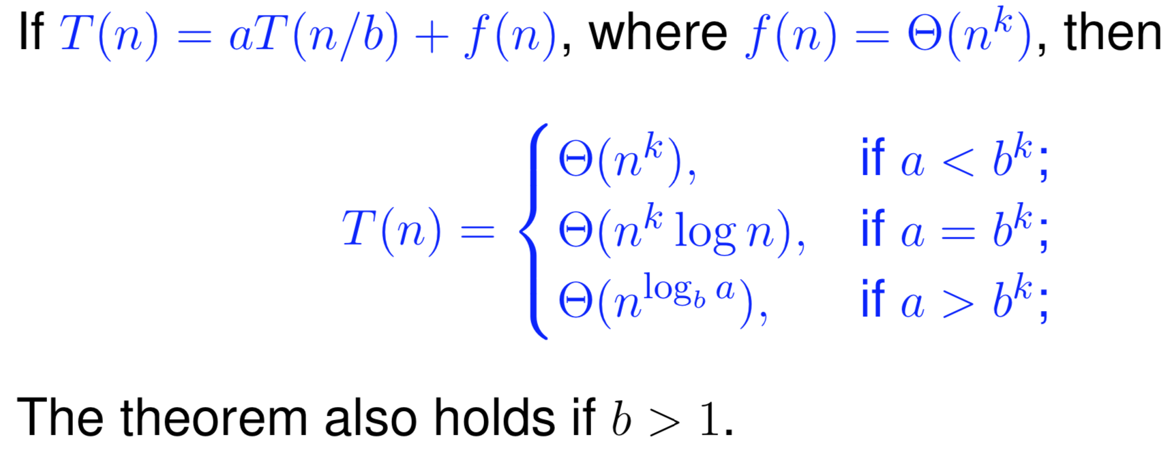

1. Example 1

C (N) = C (2N/3) + 1 2N/3 = N / (3/2)

$$a=1, b=\frac{3}{2}, f\left(N\right)=1 and f\left(n\right)∈Θ\left(n^{k}\right), therefore k=0$$

$$⇒a=1=b^{k}={\left(\frac{3}{2}\right)}^{0}$$

$$⇒C\left(N\right)∈Θ\left(N^{k}logN\right)=Θ\left(logN\right)$$

1. Example 2

T(n) = 2T(n/2) + cn

A = 2, b = 2, k = 1, $b^{k} = 2=> a = b^{k}$ => $T\left(n\right)∈Θ(nlogn)$

1. Example 3

C(n) = 2C(n/2) + n – 1

a = 2, b = 2, k = 1, therefore $a=b^{k}$

According to Master theorem, we have

$$C\left(n\right)∈Θ\left(n^{k}logn\right)$$

$$C\left(n\right)∈Θ\left(nlogn\right)$$

# Exercises: Solve the following recurrence relations with Master theorem

1. CN = CN/2 + 1000
2. CN = 3CN/2 + N
3. C (N) = 2C (N/2) + 1
4. CN = 4cN/2 + N
5. C (N) = 9C (N/3) + N
6. C (N) = C (2N/3) + 1
7. C (N) = 3C (N/4) + N2